**1 Favorite Quote**

“⸢This story is for just that one reader.⸥”

― Singshong, Omniscient Reader's Viewpoint Epilogue

**Short bio (50-150 words max)**

Syakir Sew. Addicted to reading. And learning. Mostly reading. Dabbles in everything he’s interested in, but can’t commit for the life of him. Can do anything as long as he has time and pokcik Google. He’s lately thinking about how to get more money, as all mortals do. Lastly, kenapa katak melompat?

Sebab dia ingat dia rabbit. Heh.

**socmed handle or email**

Instagram: Mess_4502

E-mail: syakirsew@gmail.com

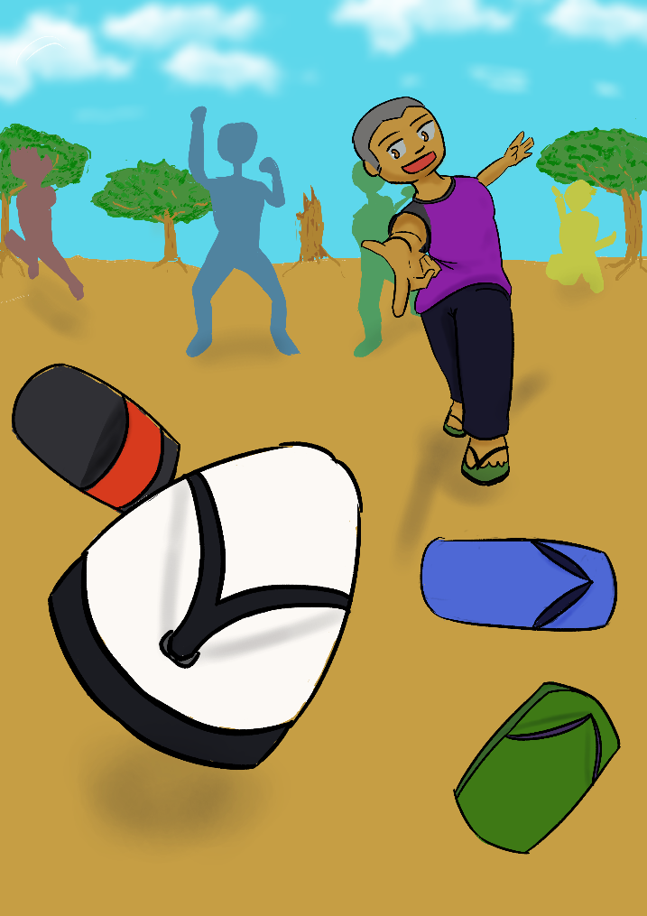

Title: Baling Selipar

Description: Created in Illustration class with the concept of nostalgia, this AR art is about a boy playing ‘baling selipar’ with his friends.

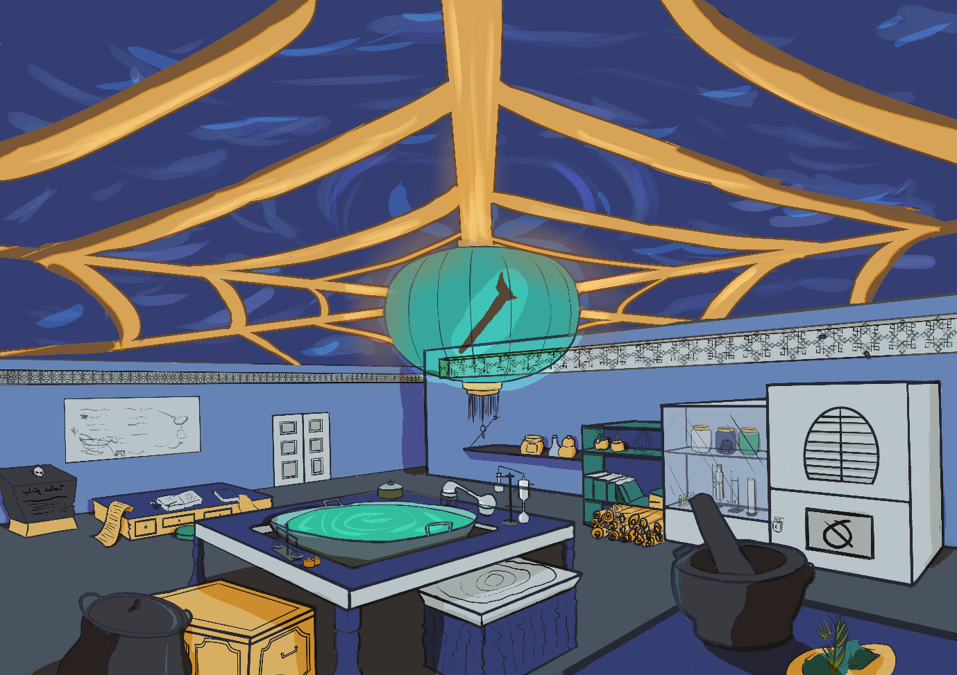

Title: Lab Under the Sea

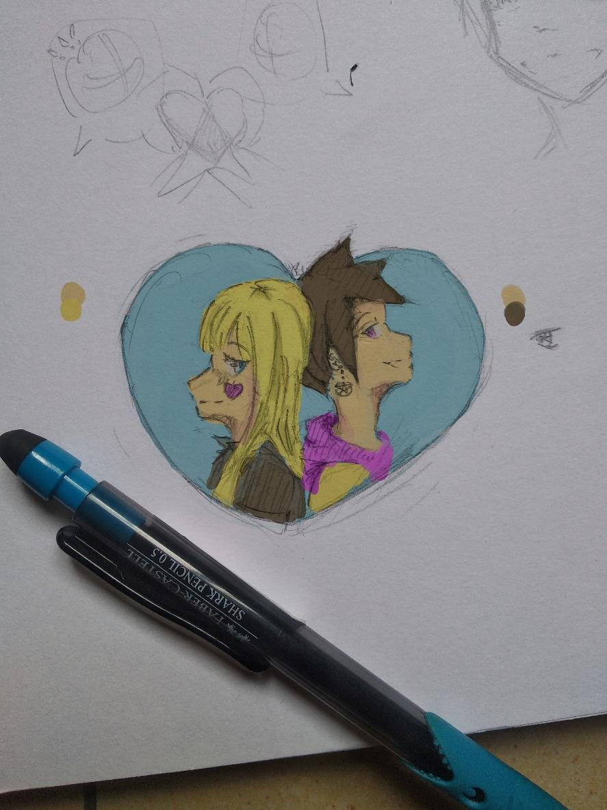

Title: Love and Star

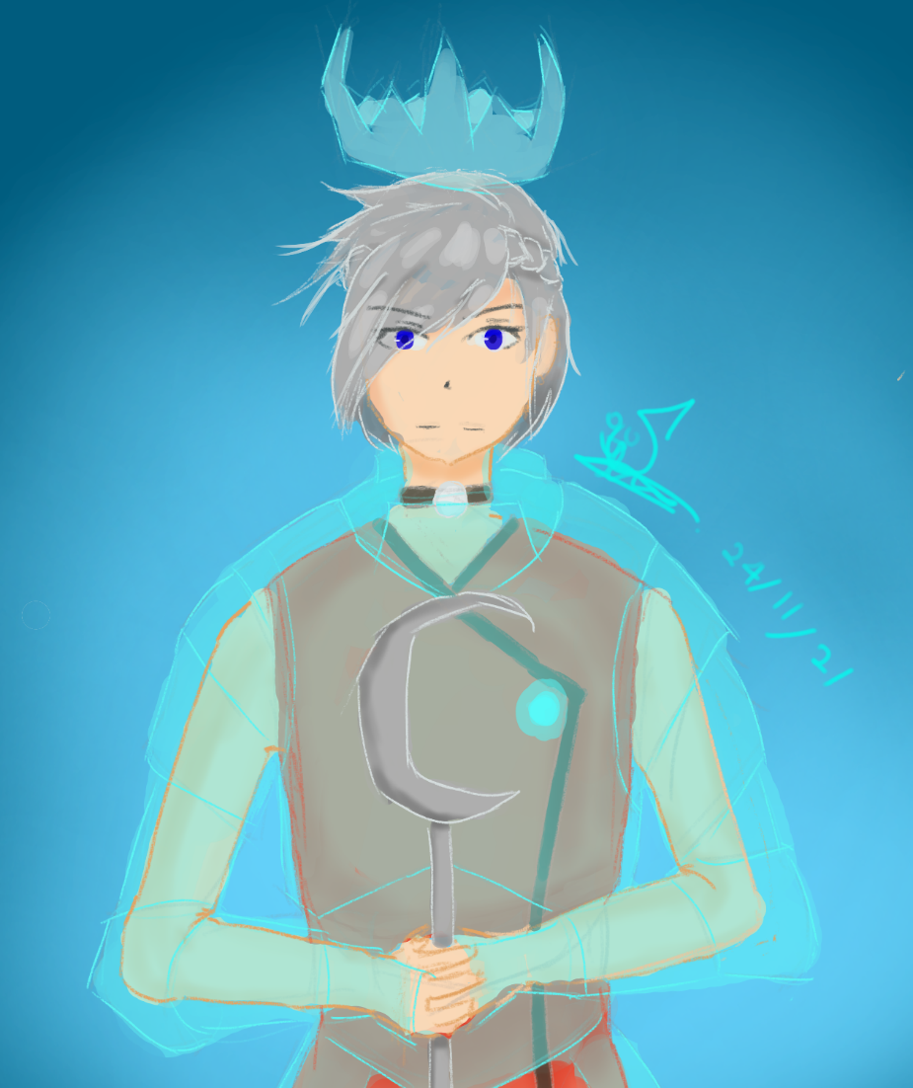

Title: Royalty

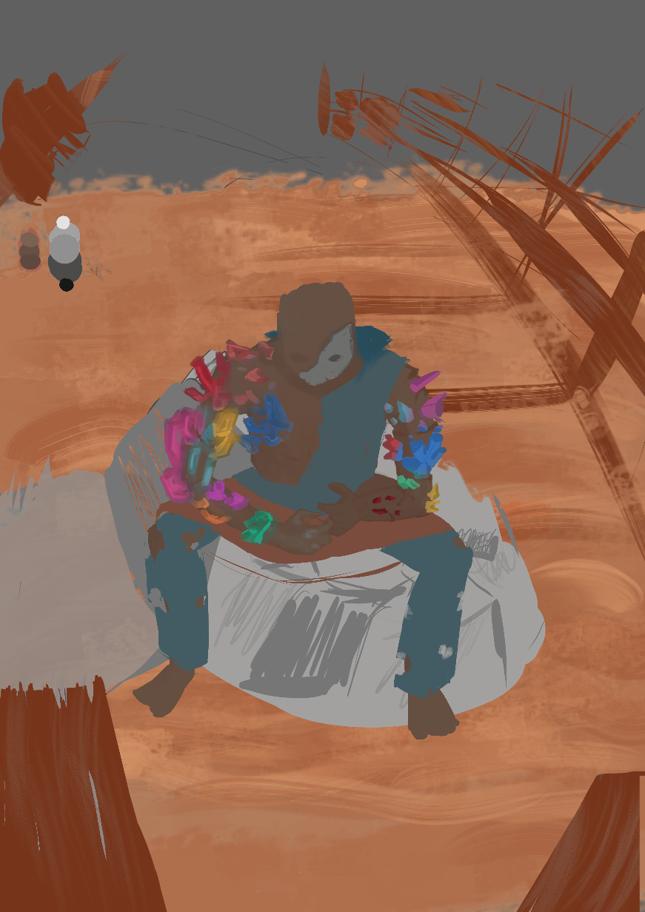

Title: Tanggang

Description: an unfinished concept of what happens to Tanggang after decades or centuries after his story.

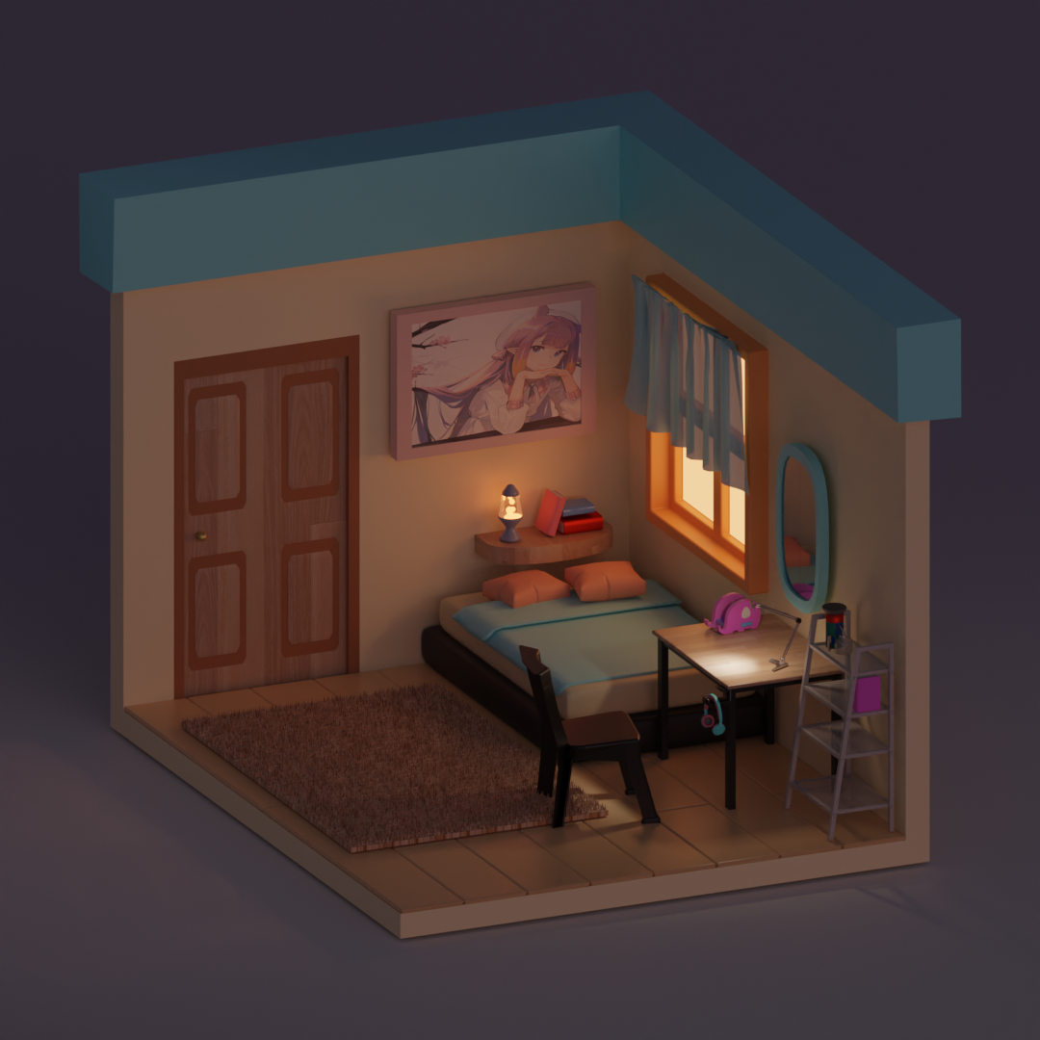

Title: Isometric Room

Description: A room of personal items

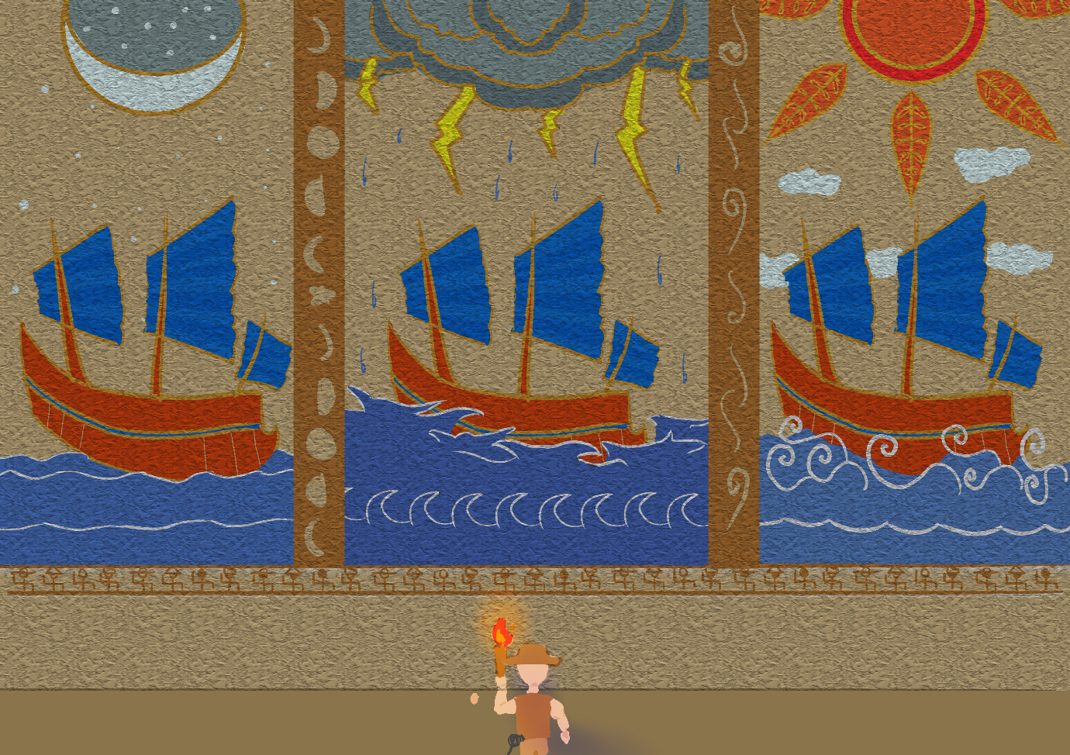

Title: Batik Mural

Description: Created during Illustration class, the art depicts an archaeologist discovering a mural of ships during various weathers using the style of batik.

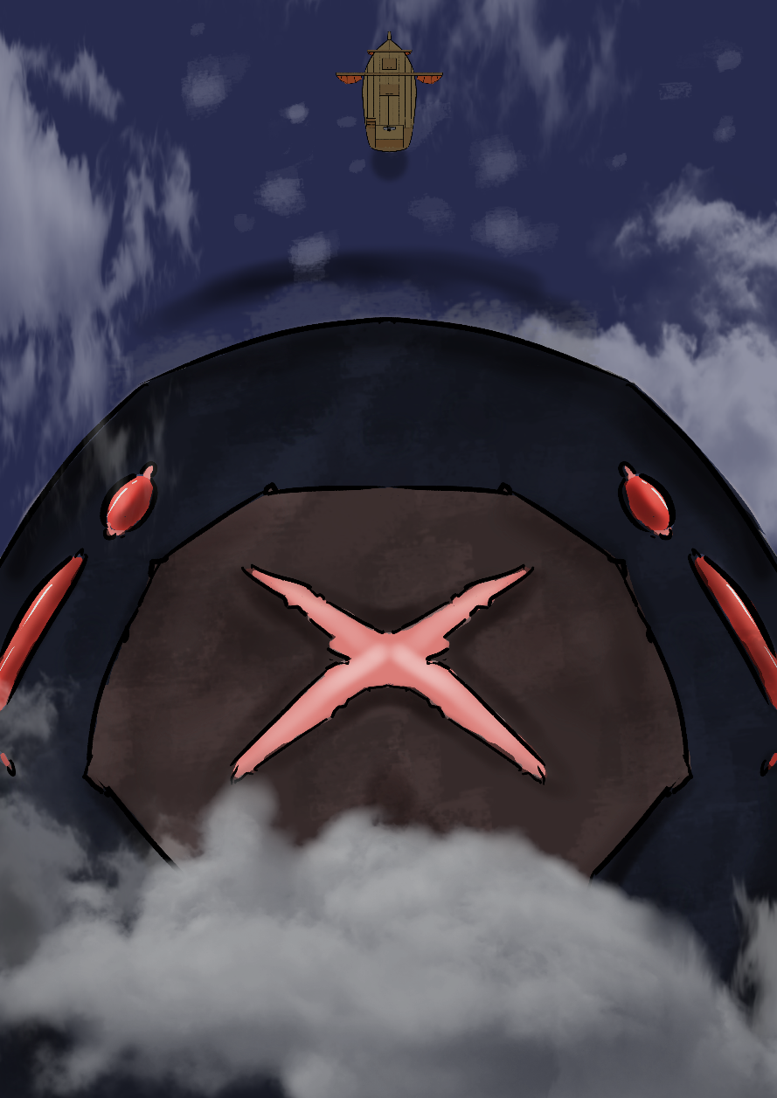

Title: Snow Giant

Description: An image of the Snow Giant, the infamous beast in my final year project animation.

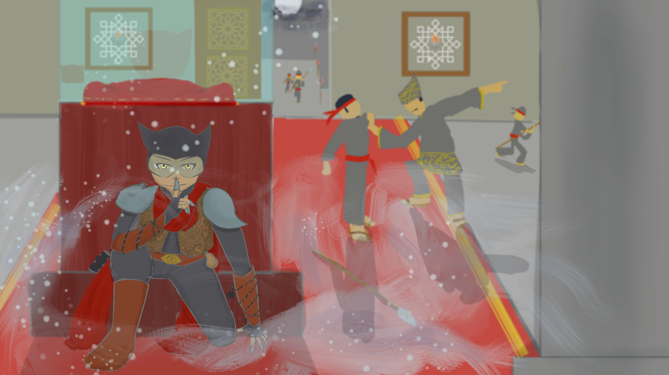

Title: Nusantara Catwoman

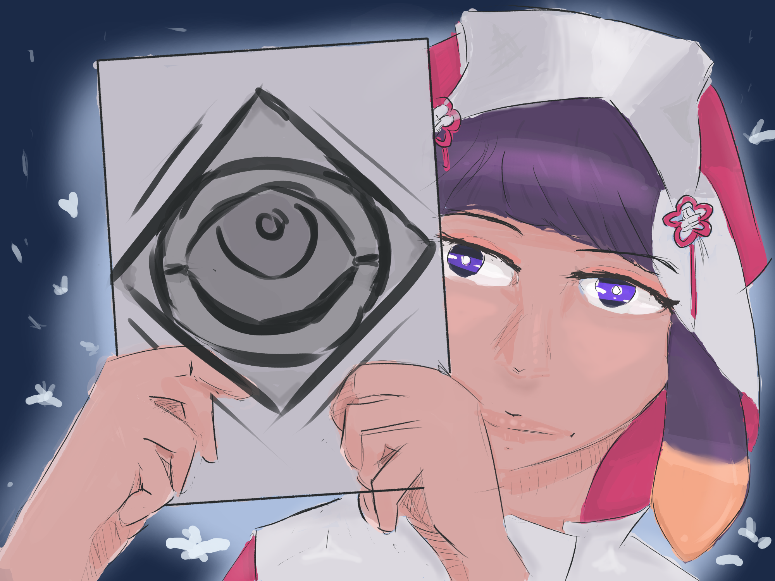

Title: Ina the Priestess